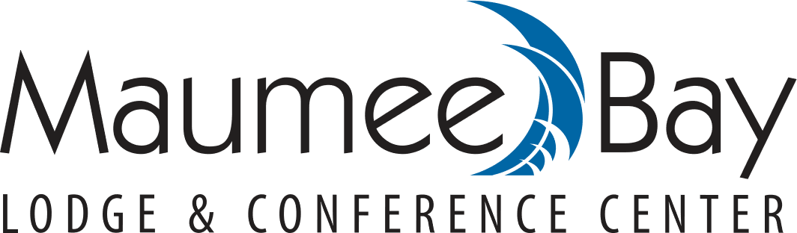

ARTIST IN RESIDENCE PROGRAM 2021 SEASON

Maumee Bay Lodge is seeking artists to participate in our Artist in Residency Program for the 2021 season running from January 1 through June 1, 2021. We offer residencies at the Maumee Bay Lodge Lobby.

Our resort offers accommodations and amenities second to none and we would like artists’ works to represent the beauty of Maumee Bay Lodge and Maumee Bay State Park and all it has to offer. Our guests come from all over the world and have shown a great interest in our Artists and their works.

The Lodge will collect revenue and taxes from the sale of your pieces as well as a commission of 40% of gross sales. You, as the artist, are encouraged to spend significant time in your space working and promoting your art. Residencies are available from one week to three month periods based on need.

We look forward to hearing from area and national artists requesting more information and adding your talents to our amenities here at Maumee Bay Lodge.

Please contact Andrani Nelson/GM at Maumee Bay Lodge at:
anelson@maumeebaylodge.com

You may also mail in your application to:
Maumee Bay Lodge
Attn: AIR PROGRAM
1750 Park Rd 2
Oregon Ohio,43616

Name_____________________________________Email_______________________________
Address______________________________City____________State____Zip_______________
Contact Phone: _________________________________
Avg Price of Works_________________
Website: ______________________________________________________________________
Please provide a description of your work:
__________________________________________________________________________________________________________________________________________________________________________________________________________________________________________
Dates Available_________________________________________________________________
Comments:__________________________________________________________________________________________________________________________________________________

